Module 1.3 Programming Assignment
Screenshot 1: Java Installation
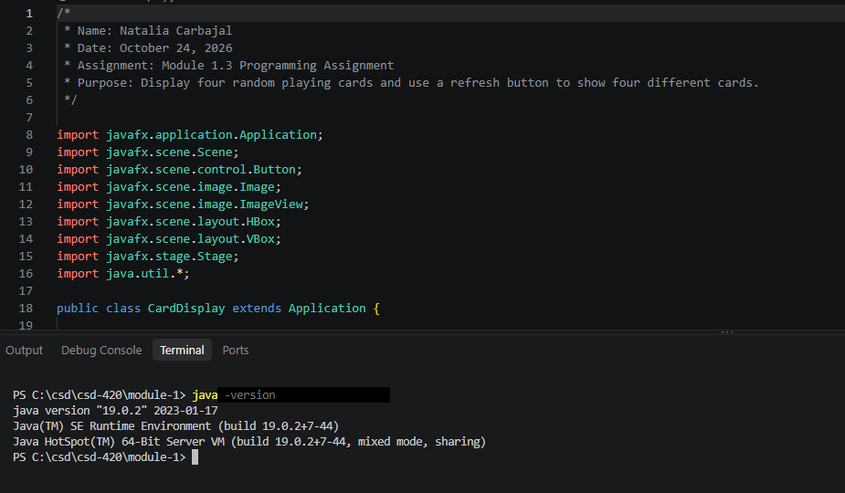
Screenshot 2: JavaFX configuration
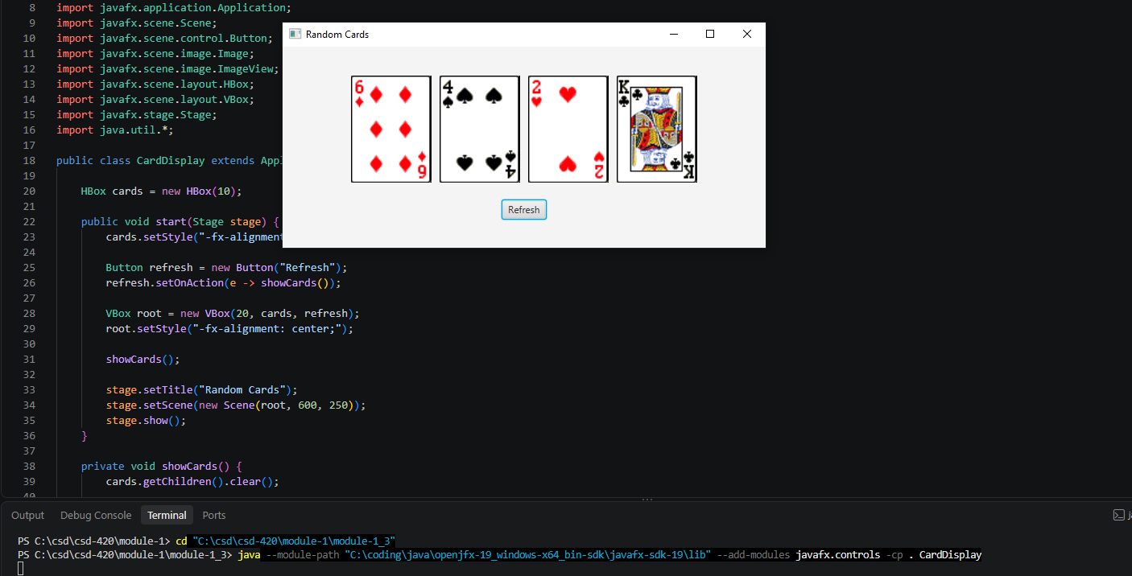
Screenshot 3: Running card application
